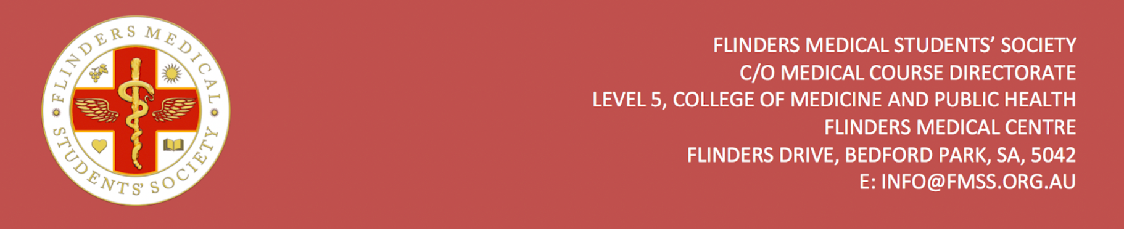
FMSS Free Membership Application Form

Flinders Medical Students’ Society provides five free memberships (worth $60 each, valid for the duration of your MD degree) at the beginning of each year for the incoming MD1 students. To apply, please complete the application from below and email it to the FMSS Vice Presidents at vpi@fmss.org.au and vpe@fmss.org.au.

Full Name
Date of Birth
Student ID
FAN
Are you an international student? If yes, where from?
Cause of financial difficulty
Do you have any individuals who are financially dependent on you?
If yes, how many?
Please write 250 words outlining your situation, how you will use the FMSS membership, and/or contribute to the medical student body.

Signature: Date:

