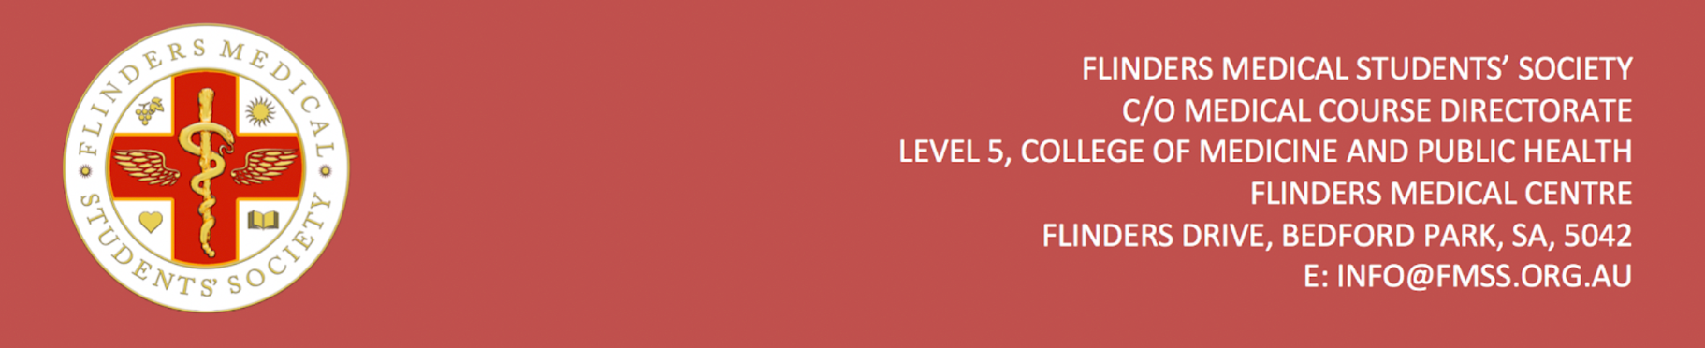
FMSS Financial Hardship Form

Flinders Medical Students’ Society provides limited $50 Woolworths or Coles gift cards for students experiencing financial hardship. To apply, please complete the application from below and email it to the FMSS Vice Presidents at vpi@fmss.org.au and vpe@fmss.org.au.

Full Name
Date of Birth
Student ID
FAN
Are you an international student? If yes, where from?
Cause of financial difficulty
Do you have any individuals who are financially dependent on you?
If yes, how many?
Please write 250 words outlining your situation and why you require financial support from FMSS.
Type of Gift Card requested | Woolworths | Coles | Other (please specify):

Signature: Date:

